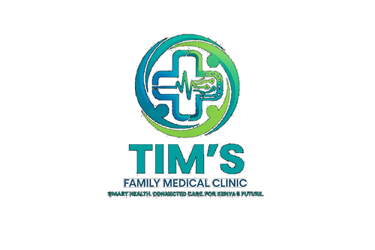 | TIM'S FAMILY MEDICAL CLINIC  Smart Health. Connected Care. For Kenya's Future.  Tel: 0715 923 231 | info@tfmc.co.ke | www.tfmc.co.ke | Nairobi, Kenya | TFMC-POL-002  Date: 17 May 2026  SHA & SHIF Accredited

PATIENT RIGHTS & RESPONSIBILITIES CHARTER
Your Rights as a TFMC Patient | Effective 2026

Tim's Family Medical Clinic (TFMC) is committed to providing safe, respectful, and dignified healthcare to every patient. This Charter sets out your rights as a patient and your responsibilities in return. It is aligned with Kenya's National Patients' Rights Charter and the Health Act 2017.
YOUR RIGHTS AS A TFMC PATIENT
1 | Right to Access Healthcare: You have the right to receive care regardless of your gender, ethnicity, religion, disability, or socioeconomic status. TFMC is a SHA/SHIF accredited provider — no Kenyan shall be denied care on grounds of inability to pay.

2 | Right to Dignity & Respect: You have the right to be treated with respect, courtesy, and dignity at all times. Verbal or physical abuse by any TFMC staff member is not acceptable and should be reported immediately.

3 | Right to Information: You have the right to receive clear, complete, and accurate information about your diagnosis, treatment options, expected outcomes, and the risks and benefits of any procedure. This information will be given in language you understand.

4 | Right to Informed Consent: No treatment, procedure, or operation will be performed on you without your informed consent. You have the right to ask questions and take time to decide. You may refuse treatment — and your decision will be respected.

5 | Right to Confidentiality & Privacy: Your medical information is strictly confidential. It will not be shared with anyone outside your care team without your consent, except as required by law.

6 | Right to a Second Opinion: You have the right to seek a second medical opinion without this affecting the quality of care you receive at TFMC.

7 | Right to Safe Care: You have the right to receive care that meets accepted medical standards and that is provided in a clean, safe environment.

8 | Right to Complain: You have the right to raise a complaint, concern, or compliment about your care without fear of reprisal. All complaints are taken seriously and investigated fairly.

9 | Right to Your Medical Records: You have the right to access your medical records and to request copies. A reasonable administrative fee may apply for copying.

10 | Right to Continuity of Care: You have the right to continuity of care and to be referred to a specialist or higher-level facility if your condition requires care beyond TFMC's scope.

YOUR RESPONSIBILITIES AS A TFMC PATIENT
To enable us to provide safe, high-quality care, we ask you to:
- Provide accurate and complete information about your health, medical history, medications, and allergies.
- Inform your TFMC doctor of any changes in your condition or if your symptoms worsen between visits.
- Follow the treatment plan agreed with your doctor, including taking medications as prescribed.
- Attend scheduled appointments on time or cancel with at least 24 hours notice so another patient can use the slot.
- Treat all TFMC staff, fellow patients, and visitors with respect and dignity at all times.
- Respect the privacy and confidentiality of other patients.
- Pay your consultation and applicable co-payment fees promptly. If you are unable to pay, please speak to our social welfare desk before receiving services.
- Avoid bringing unauthorised persons into clinical areas — only one chaperone permitted in consultation rooms.
- Refrain from using mobile phones during consultations unless in an emergency.
- Do not bring alcohol or controlled substances onto TFMC premises.
HOW TO MAKE A COMPLAINT OR COMPLIMENT
TFMC takes all feedback seriously. We use it to improve our services.
In person: Speak to any TFMC staff member or ask to see the Facility Manager on duty
Written complaint box: Located at TFMC reception
Email: complaints@tfmc.co.ke
Phone: 0715 923 231
Online: tfmc.co.ke — contact page
All complaints will be acknowledged within 2 working days and investigated within 14 working days. If you remain unsatisfied, you may escalate to the Kenya Medical Practitioners and Dentists Council (KMPDC) or the Kenya Nursing Council (KNC).

TFMC-POL-002 | Version 1.0 | Effective 1 January 2026 | complaints@tfmc.co.ke | 0715 923 231

