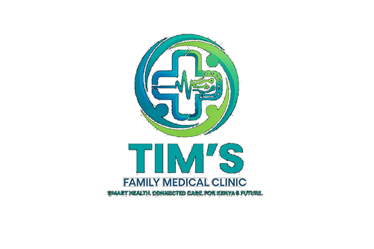 | TIM'S FAMILY MEDICAL CLINIC  Smart Health. Connected Care. For Kenya's Future.  Tel: 0715 923 231 | info@tfmc.co.ke | www.tfmc.co.ke | Nairobi, Kenya | TFMC-PROC-001  Date: 17 May 2026  SHA & SHIF Accredited

SUPPLIER REGISTRATION FORM
Expression of Interest — TFMC Approved Vendor Registration

Tim's Family Medical Clinic (TFMC) invites expressions of interest from suppliers of medical equipment, pharmaceuticals, consumables, IT solutions, facility services, catering, and other goods and services. Complete all sections and submit to procurement@tfmc.co.ke.
SECTION A — COMPANY DETAILS
Registered Company Name *

Trading Name (if different)

Company Registration No. * | As on Certificate of Incorporation

KRA PIN *

VAT Registration No. (if applicable)

Date of Incorporation | DD/MM/YYYY

County of Registration

Physical Address *

Postal Address

Company Website

Company Email *

Company Phone *

SECTION B — CONTACT PERSONS
Primary Contact Name *

Title / Designation

Primary Contact Phone *

Primary Contact Email *

Accounts Contact Name

Accounts Contact Phone

Accounts Contact Email

SECTION C — CATEGORIES OF SUPPLY
Tick all categories applicable to your company:
☐ Medical Equipment & Devices | ☐ Pharmaceutical Products & Medicines
☐ Medical Consumables & Disposables | ☐ Laboratory Reagents & Supplies
☐ Office Furniture & Fittings | ☐ ICT Equipment & Software
☐ Cleaning & Janitorial Services | ☐ Catering & Canteen Services
☐ Security Services | ☐ Maintenance & Repair Services
☐ Printing & Stationery | ☐ Linen & Laundry Services
☐ Other (specify below)

Other categories | Specify if not listed above

SECTION D — BUSINESS INFORMATION
Years in Operation

Number of Employees | Approximate

Annual Turnover (KES) | Approximate — for pre-qualification purposes

Banker Name & Branch

Bank Account Number

M-Pesa Paybill / Till No. | If applicable

Major Clients (last 3 years) | List name, sector, and contact — minimum 2 references

SECTION E — DOCUMENTS TO ATTACH
- Certificate of Incorporation / Business Registration (copy)
- KRA Tax Compliance Certificate (current)
- VAT Certificate (if VAT registered)
- CR12 (Certificate of Directors) — for limited companies
- Professional licences (PPB, KEBS, etc.) where applicable
- Manufacturer / principal authorisation letters (if applicable)
- Company profile (2 pages maximum)
- References from at least 2 previous clients in healthcare
- Bank reference letter
SECTION F — DECLARATION
I/We declare that the information provided in this form is accurate and complete. I/We understand that providing false information will result in immediate disqualification from TFMC's vendor database. I/We authorise TFMC to verify any information provided herein.

_________________________ | _________________________
Director / Authorised Signatory | Company Stamp
Date: _________________ | Date: _________________

Submit completed form and all attachments to: procurement@tfmc.co.ke | Tel: 0715 923 231

Supplier registration does not guarantee award of business. TFMC reserves the right to remove any supplier from its register at any time. | procurement@tfmc.co.ke

