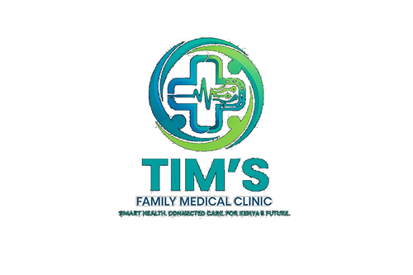 | TIM'S FAMILY MEDICAL CLINIC  Smart Health. Connected Care. For Kenya's Future.  Tel: 0715 923 231 | info@tfmc.co.ke | www.tfmc.co.ke | Nairobi, Kenya | TFMC-GUIDE-006  Date: 17 May 2026  SHA & SHIF Accredited

KENYA CHILDHOOD IMMUNISATION SCHEDULE
Ministry of Health Kenya | All vaccines FREE at TFMC and Government Facilities

Immunisation is one of the most effective ways to protect your child from serious and potentially fatal diseases. Kenya's routine immunisation schedule protects against 13 diseases. All vaccines on this schedule are FREE at TFMC and government health facilities.
ROUTINE IMMUNISATION SCHEDULE (MOH Kenya)
Age | Vaccine | Diseases Protected Against
Birth | BCG | Tuberculosis (TB) — scar appears on upper left arm
Birth | OPV 0 (Oral Polio Vaccine) | Poliomyelitis
6 weeks | OPV 1 | Poliomyelitis
6 weeks | DPT-HepB-Hib 1 | Diphtheria, Pertussis, Tetanus, Hepatitis B, Hib meningitis
6 weeks | PCV 1 (Pneumococcal) | Pneumonia, meningitis
6 weeks | Rotavirus 1 | Rotavirus diarrhoea (leading cause of diarrhoea death in children)
10 weeks | OPV 2 | Poliomyelitis
10 weeks | DPT-HepB-Hib 2 | Diphtheria, Pertussis, Tetanus, Hepatitis B, Hib
10 weeks | PCV 2 | Pneumonia, meningitis
10 weeks | Rotavirus 2 | Rotavirus diarrhoea
14 weeks | OPV 3 | Poliomyelitis
14 weeks | IPV 1 (Inactivated Polio) | Poliomyelitis (injectable, for stronger immunity)
14 weeks | DPT-HepB-Hib 3 | Diphtheria, Pertussis, Tetanus, Hepatitis B, Hib
14 weeks | PCV 3 | Pneumonia, meningitis
9 months | MR 1 (Measles-Rubella) | Measles and Rubella
9 months | Yellow Fever | Yellow Fever (endemic areas: western Kenya, Coast)
9 months | Vitamin A | Vitamin A deficiency prevention
18 months | MR 2 | Measles-Rubella booster
18 months | DPT booster | Diphtheria, Pertussis, Tetanus
18 months | OPV booster | Poliomyelitis
18 months | Vitamin A | 6-monthly until 5 years
10 years (Girls) | HPV Vaccine | Cervical cancer prevention (2 doses, 6 months apart)

IMPORTANT NOTES FOR PARENTS
- Keep your child's immunisation card safe — bring it to every visit including TFMC OPD.
- Never miss a scheduled dose — delayed immunisation leaves your child unprotected.
- If a dose is missed, do not restart — continue from where you left off. TFMC nurses will advise.
- Side effects are usually mild: small lump at injection site, low fever, mild crying. These resolve in 1–2 days.
- Paracetamol syrup can be given after vaccines if your child develops fever — ask TFMC pharmacy for correct dose.
- Serious reactions are very rare. Go to hospital immediately if child has difficulty breathing or severe rash after vaccine.
- All vaccines on this schedule are FREE at TFMC and all government health facilities in Kenya.
- Additional vaccines (not on routine schedule): Typhoid, Meningococcal, Varicella, Hepatitis A — available at TFMC pharmacy at cost.
Book your child's next immunisation at TFMC: 0715 923 231 | appointments@tfmc.co.ke

Source: MOH Kenya Expanded Programme on Immunisation (KEPI) 2024. | 0715 923 231 | info@tfmc.co.ke

