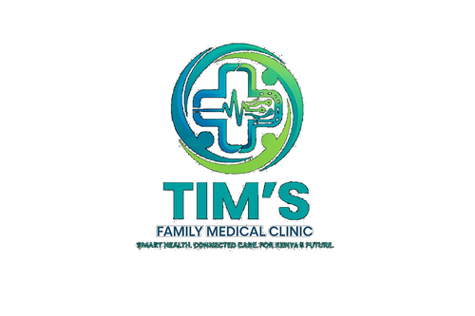 | TIM'S FAMILY MEDICAL CLINIC  Smart Health. Connected Care. For Kenya's Future.  Tel: 0715 923 231 | info@tfmc.co.ke | www.tfmc.co.ke | Nairobi, Kenya | TFMC-GUIDE-005  Date: 17 May 2026  SHA & SHIF Accredited

HOW TO USE YOUR SHA / SHIF CARD AT TFMC
Step-by-Step Guide for Patients | SHA & SHIF Accredited Provider

Tim's Family Medical Clinic (TFMC) is an accredited Social Health Authority (SHA) and SHIF (Social Health Insurance Fund) provider. Your SHA/SHIF card covers many healthcare services at no out-of-pocket cost. This guide explains exactly how to access your benefits at TFMC.
WHAT IS SHA / SHIF?
SHA (Social Health Authority) is Kenya's universal health coverage scheme, replacing NHIF from 2024. Every Kenyan household is registered. SHIF (Social Health Insurance Fund) is the contributory scheme within SHA — employed persons contribute based on salary, others contribute KES 500/month.
Your SHA benefits include: outpatient care, laboratory tests, pharmacy, maternity care, chronic disease management, and emergency care at accredited facilities like TFMC.
STEP-BY-STEP GUIDE AT TFMC
1 | Step 1 — Arrive at TFMC reception  Present your SHA/SHIF card (physical or digital on Afya Yangu app) at registration. Ensure your card is active and not suspended.

2 | Step 2 — Registration  Our Health Records Officer will verify your SHA/SHIF number on the SHA portal. This takes 2–3 minutes. Bring your National ID as a backup.

3 | Step 3 — Consultation  See the doctor as normal. The doctor will document your diagnosis using ICD-10 codes as required by SHA.

4 | Step 4 — Lab Tests  If tests are requested, take the lab request form to our laboratory. Show your SHA card — eligible tests will be billed to SHA directly.

5 | Step 5 — Pharmacy  Collect your prescription at our pharmacy. Show your SHA card — SHA-covered medications on the Essential Medicines List are dispensed at no charge.

6 | Step 6 — Billing  Our billing team submits your claim to SHA electronically. You sign the claim summary. No cash payment required for covered services.

7 | Step 7 — Co-payments  Some services have small co-payments that SHA does not cover. Our billing team will tell you in advance. M-Pesa and cash accepted.

8 | Step 8 — Follow-up  Book your follow-up appointment at reception. For chronic conditions (diabetes, hypertension, HIV, TB) — regular follow-up is covered by SHA.

WHAT IS COVERED BY SHA AT TFMC?
Service | SHA Coverage
Outpatient consultation | Fully covered
Laboratory tests (selected) | Fully covered for SHA Essential tests
Essential medicines (KEML) | Fully covered on prescription
ANC (all 8 visits) | Fully covered
Immunisations | Fully covered
HIV testing and ART | FREE — fully subsidised
TB diagnosis and treatment | FREE — fully subsidised
Chronic disease management | Covered with co-payment
Emergency care | Covered up to SHA emergency benefit limits

IF YOUR SHA CARD IS NOT WORKING
- Ensure your SHA registration is complete — visit any Huduma Centre to update registration.
- Ensure your SHIF contributions are up to date — check on the Afya Yangu app or SHA portal.
- If card is suspended: pay outstanding contributions at any Safaricom M-Pesa paybill 200222.
- Contact SHA call centre: 0800 723 904 (toll-free).
- If SHA cannot be verified at TFMC, you will be served on a cash basis and can seek SHA reimbursement separately.
For assistance with SHA at TFMC, speak to our Health Records Officer at registration or call 0715 923 231.

Tim's Family Medical Clinic Limited | Nairobi, Kenya | 0715 923 231 | info@tfmc.co.ke | 17 May 2026

