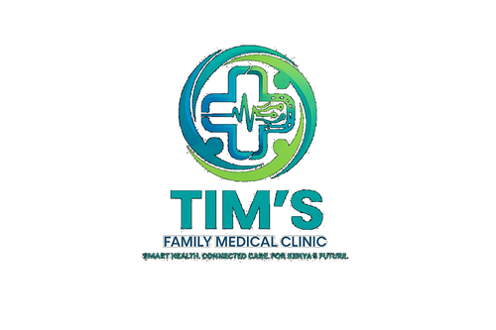 | TIM'S FAMILY MEDICAL CLINIC  Smart Health. Connected Care. For Kenya's Future.  Tel: 0715 923 231 | info@tfmc.co.ke | www.tfmc.co.ke | Nairobi, Kenya | TFMC-GUIDE-004  Date: 17 May 2026  SHA & SHIF Accredited

ANTENATAL CARE (ANC) SCHEDULE & PREGNANCY GUIDE
WHO 8-Contact Programme | SHA & SHIF Covered | TFMC Maternity Services

Congratulations on your pregnancy! Antenatal care (ANC) visits are essential for a safe pregnancy and healthy baby. WHO recommends at least 8 ANC contacts. TFMC provides comprehensive ANC services covered by SHA and SHIF.
YOUR 8-CONTACT ANC SCHEDULE
Visit | Gestation | Key Activities | TFMC Tests
1st Contact | Before 12 weeks | Registration, full history, risk assessment, nutrition counselling, birth planning | FBC, Blood Group, HIV, VDRL, Urine dipstick, Hepatitis B, Diabetes screen, TB screen
2nd Contact | 20 weeks | Fetal growth assessment, BP check, urine test, ultrasound referral if not done | Urine dipstick, BP, FBC if anaemic
3rd Contact | 26 weeks | BP, weight, fundal height, fetal movements, IPTp 2nd dose (malaria prevention) | Urine, BP, Hb
4th Contact | 30 weeks | BP, weight, fetal position, birth plan review | Urine, BP
5th Contact | 34 weeks | BP, weight, fetal position, anaemia check, Group B Strep where indicated | FBC, Urine, BP
6th Contact | 36 weeks | Fetal position check (if breech — plan), breastfeeding counselling | Urine, BP
7th Contact | 38 weeks | BP, weight, fetal position, warning signs review | Urine, BP
8th Contact | 40 weeks | Post-dates management, birth plan finalisation, labour signs | Urine, BP, NST if available

ROUTINE MEDICATIONS DURING PREGNANCY
- Folic Acid: Folic Acid 400mcg daily: start before conception if possible, continue through 1st trimester. Prevents neural tube defects.
- Iron: Ferrous Sulphate (Iron) 200mg daily: from 1st ANC visit. Take with Vitamin C (orange juice) for better absorption.
- IPTp Fansidar: IPTp (Intermittent Preventive Treatment for Malaria): Fansidar given 3+ times from 13 weeks in malaria-endemic areas — FREE at TFMC.
- Calcium: Calcium 1.5g daily: from 20 weeks for women at risk of pre-eclampsia.
- Cost: All ANC medications are FREE under SHA/SHIF at TFMC.
NUTRITION DURING PREGNANCY
- Eat 3 balanced meals plus 2 snacks daily. Caloric needs increase by ~300 kcal/day in 2nd and 3rd trimesters.
- Iron-rich foods: red meat, liver, beans (njahi, green grams), dark leafy vegetables (sukuma wiki, spinach).
- Calcium: milk, yoghurt, fish with bones (omena), dark leafy vegetables.
- Protein: eggs, fish, chicken, beans, lentils — essential for baby's growth.
- Avoid: alcohol completely, raw meat, unpasteurised milk, excessive caffeine (max 1 cup/day).
- Take folic acid and iron supplements even if eating well — food alone is rarely enough.
DANGER SIGNS IN PREGNANCY — ATTEND HOSPITAL IMMEDIATELY
Go to the nearest maternity hospital immediately for any of these warning signs:
- Heavy vaginal bleeding at any stage of pregnancy
- Severe headache, blurred vision, or seeing spots (pre-eclampsia)
- Severe swelling of face, hands, or feet
- Reduced or absent fetal movements after 28 weeks
- High fever (above 38.5°C)
- Severe abdominal pain
- Difficulty breathing
- Convulsions or fits
- Sudden gush of water from the vagina (possible premature rupture of membranes)
PREPARING FOR BIRTH
- Plan where you will deliver: hospital or maternity facility — home delivery is not recommended.
- Arrange transport to the maternity facility in advance — know who will take you at any hour.
- Prepare your delivery bag by 36 weeks: clothes for you and baby, ID/SHIF card, ANC card, sanitary pads.
- Know the signs of labour: regular contractions every 5 minutes, show (pink discharge), water breaking.
- Breastfeed within 1 hour of delivery — colostrum (first milk) is essential for baby's immunity.
All ANC visits at TFMC are covered by SHA and SHIF. Book your first ANC visit as early as possible — ideally before 12 weeks. Call 0715 923 231.

This guide is for health education only. Always attend all 8 ANC visits and follow your midwife's advice. | 0715 923 231 | info@tfmc.co.ke

