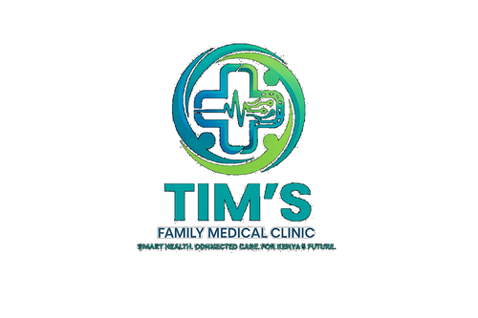 | TIM'S FAMILY MEDICAL CLINIC  Smart Health. Connected Care. For Kenya's Future.  Tel: 0715 923 231 | info@tfmc.co.ke | www.tfmc.co.ke | Nairobi, Kenya | TFMC-GUIDE-003  Date: 17 May 2026  SHA & SHIF Accredited

MANAGING HYPERTENSION
Understanding and Controlling High Blood Pressure | TFMC Health Education Series

WHAT IS HYPERTENSION?
Hypertension (high blood pressure) is a condition where the force of blood against your artery walls is persistently too high. It is called the 'silent killer' because most people have NO symptoms until serious damage has already occurred to the heart, kidneys, brain, or eyes.
1 in 4 Kenyan adults has hypertension. Only 1 in 3 of those know they have it. Regular BP screening at TFMC is essential — it takes 2 minutes and could save your life.
UNDERSTANDING YOUR BLOOD PRESSURE READING
Category | Systolic (mmHg) | Diastolic (mmHg)
Normal | Below 120 | Below 80
Elevated | 120–129 | Below 80
Stage 1 Hypertension | 130–139 | 80–89
Stage 2 Hypertension | 140 or above | 90 or above
Hypertensive Crisis (EMERGENCY) | Above 180 | Above 120

LIFESTYLE CHANGES — THE FOUNDATION OF TREATMENT
Even with medication, lifestyle changes are essential. Many patients can reduce or eliminate medication with sustained lifestyle improvement:
- Salt: Salt reduction: use less than 5g (1 teaspoon) of salt per day. Avoid processed foods, canned soups, soy sauce, and stock cubes which are very high in sodium.
- Exercise: Exercise: 30 minutes of moderate activity (brisk walking) on most days. Reduces BP by 5–8 mmHg.
- Weight loss: Weight: losing even 5–10% of body weight can reduce BP by 5–20 mmHg.
- Alcohol: Alcohol: limit to maximum 1–2 units per day. Avoid binge drinking which causes acute BP spikes.
- Smoking: Smoking: quit smoking completely. Every cigarette raises BP for 30 minutes.
- Stress: Stress: chronic stress elevates BP. Prayer, rest, exercise, and social support all help.
- Diet: Diet: eat more fruits and vegetables, potassium-rich foods (bananas, sweet potatoes, avocado), and less red meat and fried foods.
MEDICATIONS
Commonly used in Kenya — your TFMC doctor will choose based on your age, other conditions, and side effect profile:
- Amlodipine: Amlodipine (calcium channel blocker) — first-line. May cause ankle swelling.
- ACE Inhibitors: Enalapril / Lisinopril (ACE inhibitor) — protects kidneys. Avoid in pregnancy. May cause dry cough.
- HCTZ: Hydrochlorothiazide (diuretic) — reduces fluid. Monitor electrolytes.
- Nifedipine: Nifedipine SR (long-acting) — for difficult-to-control BP.
- IMPORTANT: CRITICAL: Do NOT stop BP medication even if you feel well. Stopping suddenly can cause a dangerous BP spike.
MONITORING YOUR BLOOD PRESSURE
- Check BP at every TFMC visit — free of charge
- Home BP monitoring: purchase a validated automatic BP machine (from KES 2,500 at most pharmacies)
- Take BP at the same time each morning before medication
- Rest for 5 minutes before checking. Sit with back supported and feet flat
- Record all readings and bring your logbook to TFMC appointments
- Target: below 130/80 mmHg for most patients. Below 140/90 for elderly patients
EMERGENCY WARNING SIGNS
Go to hospital IMMEDIATELY if you experience:
- Sudden severe headache (worst of your life)
- Chest pain
- Shortness of breath at rest
- Sudden vision changes or loss
- Sudden weakness of face, arm, or leg (stroke)
- Confusion or loss of consciousness
- BP above 180/120 mmHg
SHA and SHIF cover hypertension consultations and most medications at TFMC. Free BP screening at every visit. Book: 0715 923 231.

This guide is for health education only. Always follow your TFMC doctor's specific advice. | 0715 923 231 | info@tfmc.co.ke

