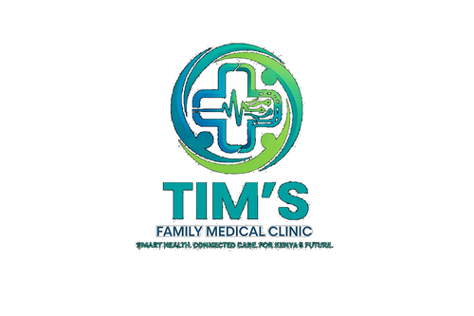 | TIM'S FAMILY MEDICAL CLINIC  Smart Health. Connected Care. For Kenya's Future.  Tel: 0715 923 231 | info@tfmc.co.ke | www.tfmc.co.ke | Nairobi, Kenya | TFMC-FORM-003  Date: 17 May 2026  SHA & SHIF Accredited

SHA / SHIF OUTPATIENT CLAIM FORM
Social Health Authority — Outpatient Claim | TFMC SHA Provider Code: [CODE]

This form is used by TFMC billing staff to process SHA and SHIF claims for outpatient services. Patients must present a valid SHA or SHIF card at registration.

PART A — PROVIDER INFORMATION
Provider Name | Tim's Family Medical Clinic Limited
Provider Code | [SHA Provider Code — apply at SHA portal]
Provider Type | Outpatient — Level 2 Facility
County | Nairobi County

PART B — PATIENT DETAILS
Patient Full Name *

SHA / SHIF No. * | As on card

Date of Birth * | DD/MM/YYYY

Gender * | M / F

ID / Passport No. *

Phone Number

Benefit Package | Primary Care / Chronic Disease / Maternity / Emergency

PART C — CLINICAL INFORMATION
Date of Visit * | DD/MM/YYYY

Time of Visit | HH:MM

Presenting Complaint *

Primary Diagnosis (ICD-10) * | e.g. E11.9 — Type 2 diabetes without complications

Secondary Diagnosis

Attending Clinician *

KMPDC / NCK No. *

PART D — SERVICES PROVIDED
Service / Item | Code | Quantity | Amount (KES)
SHA / SHIF Covered Amount (KES)
Patient Co-payment (KES)
Total Claim Amount (KES)

PART E — DECLARATIONS
Clinician Declaration: I certify that the services listed above were provided to the patient named herein and that the diagnoses and treatments are accurate to the best of my knowledge.

_________________________ | _________________________
Attending Clinician Signature | Medical Officer In-Charge
Date: _________________ | Date: _________________

Patient / Agent Declaration: I confirm I received the services listed above.

_________________________ | _________________________
Patient / Agent Signature | Date
Date: _________________ | Date: _________________

This claim form is for TFMC internal use. Retain copy for 7 years per SHA regulations. Enquiries: info@tfmc.co.ke | 0715 923 231

