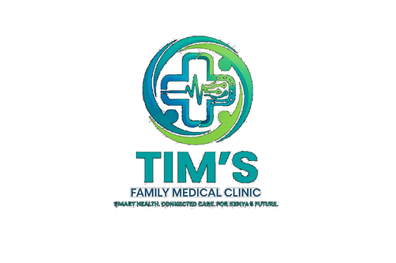 | TIM'S FAMILY MEDICAL CLINIC  Smart Health. Connected Care. For Kenya's Future.  Tel: 0715 923 231 | info@tfmc.co.ke | www.tfmc.co.ke | Nairobi, Kenya | TFMC-FORM-002  Date: 17 May 2026  SHA & SHIF Accredited

NEW PATIENT REGISTRATION FORM
Complete this form before or during your first visit to TFMC

PERSONAL DETAILS
Surname *

First Name *

Middle Name

Date of Birth * | DD / MM / YYYY

Gender * | Male / Female / Other

Marital Status | Single / Married / Widowed / Divorced

Nationality | e.g. Kenyan

National ID / Passport *

County of Origin

CONTACT INFORMATION
Mobile Number *

Alternative Number

Email Address

Postal Address

Physical Address

Nearest Landmark

NEXT OF KIN
Name *

Relationship *

Phone *

Alternative Phone

Address

HEALTH INFORMATION
Blood Group | A+ / A- / B+ / B- / O+ / O- / AB+ / AB- (or Unknown)

Current Medical Conditions | e.g. diabetes, hypertension, asthma — state None if none

Known Allergies | Drugs, food, environment — state None if none

Current Medications | Include all prescription and OTC medications — state None if none

Previous Surgeries / Hospitalisations | Include year and reason — state None if none

Family Medical History | e.g. diabetes, cancer, heart disease in parents or siblings

Do you smoke? | Yes / No — If yes, how many per day?

Alcohol use | Never / Occasionally / Regularly

INSURANCE & PAYMENT
Payment Method * | SHA / SHIF / Cash / M-Pesa / Insurance

SHA / SHIF Number | If applicable

Insurer Name | If applicable

Policy / Member No.

Insurer Phone

CONSENT & DECLARATION
I declare that the information provided is accurate and complete. I consent to Tim's Family Medical Clinic Limited collecting, storing, and using my personal and health information for the purpose of providing medical services, as permitted under Kenya's Data Protection Act 2019.

_________________________ | _________________________
Patient / Guardian Signature | Staff Receiving
Date: _________________ | Date: _________________

Tim's Family Medical Clinic Limited | Nairobi, Kenya | 0715 923 231 | info@tfmc.co.ke | 17 May 2026

