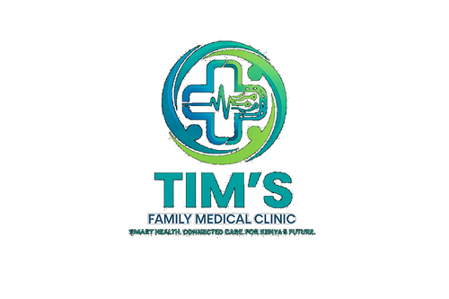 | TIM'S FAMILY MEDICAL CLINIC  Smart Health. Connected Care. For Kenya's Future.  Tel: 0715 923 231 | info@tfmc.co.ke | www.tfmc.co.ke | Nairobi, Kenya | TFMC-FORM-001  Date: 17 May 2026  SHA & SHIF Accredited

APPOINTMENT REQUEST FORM
Please complete all sections marked * and submit to appointments@tfmc.co.ke or hand in at reception

SECTION A — PATIENT INFORMATION
Full Name * | As per National ID or Passport

Date of Birth * | DD / MM / YYYY

ID / Passport No. | National ID or Passport number

Gender * | Male / Female / Other

Phone Number * | Primary contact — WhatsApp capable preferred

Alternative Phone | Optional

Email Address | Optional

Home Address

Next of Kin — Name & Phone | Emergency contact

SECTION B — PAYMENT & INSURANCE
Payment Method * | SHA / SHIF / Cash / M-Pesa / Private Insurance

SHA / SHIF Number | Present card at registration — number on card

Insurance Company | Name of insurer if applicable

Policy / Member No. | If insured

SECTION C — APPOINTMENT REQUEST
Preferred Date * | DD / MM / YYYY

Preferred Time * | Morning 7–12 / Afternoon 12–4 / Evening 4–6

Service / Department * | OPD / ANC / Lab / Pharmacy / Chronic Disease / Other

Preferred Doctor | Name or leave blank for next available

Reason for Visit * | Briefly describe your main concern or symptoms

Current Medications | List all medications including supplements — state None if none

Known Allergies | Medication, food, or environmental — state None if none known

SECTION D — CONSENT
I confirm the information above is accurate and consent to Tim's Family Medical Clinic using it to manage my appointment and health records in accordance with Kenya's Data Protection Act 2019. I understand TFMC may contact me by phone, WhatsApp or email regarding my appointment.

_________________________ | _________________________
Patient / Guardian Signature | Witness (if applicable)
Date: _________________ | Date: _________________

SECTION E — OFFICE USE ONLY
Appt No. | Doctor Assigned | Room No. | Confirmed By

Tim's Family Medical Clinic Limited | Nairobi, Kenya | 0715 923 231 | info@tfmc.co.ke | 17 May 2026

